

Darshan University

A Project Report on

“Car Service Management System ”

Under the subject

Software Engineering (2301CS405)

B. Tech, Semester – IV

Computer Science & Engineering Department

Submitted By
Student Name: Rutvik K Makvana | Enrollment No.: 24010101160
Academic Year
(2025-2026)
Internal Guide  Prof. R. B. Gondaliya  Darshan University | Dean-DIET  Dr. Gopi Sanghani  Darshan University

Computer Science & Engineering Department
Darshan University

DECLARATION

We hereby declare that the SRS, submitted along with the Software Engineering (2301CS405) for entitled “Car service Management System” submitted in partial fulfilment for the Semester-5 of Bachelor Technology (B. Tech) in Computer Science and Engineering (CSE) Department to Darshan University, Rajkot, is a record of the work carried out at Darshan University, Rajkot under the supervision of R. B. Gondaliya and that no part of any of report has been directly copied from any students’ reports, without providing due reference.

Rutvik Makvana

Student’s Signature

Date: __________

Computer Science & Engineering Department
Darshan University

CERTIFICATE

This is to certify that the SRS on “Car Service Management System” has been satisfactorily prepared by Rutvik Makvana (24010101160) under my guidance in the fulfillment of the course Software Engineering (2301CS405) work during the academic year 2025-202.

Internal Guide  Prof. R. B. Gondaliya  Darshan University |  | Dean-DIET  Dr. Gopi Sanghani  Darshan University

Acknowledgement
I wish to express my sincere gratitude to my project guide Prof. R. B. Gondaliya and all the faculty members for helping me through my project by giving me the necessary suggestions and advices along with their valuable co- ordination in completing this work.

I also thank my parents, friends and all the members of the family for their precious support and encouragement which they had provided in completion of my work. In addition to that, I would also like to mention the Darshan University personals who gave me the permission to use and experience the valuable resources required for the project from the University premises.

Thus, in conclusion to the above said, I once again thank the faculties and members of Darshan University for their valuable support in completion of the project.

Thanking You
Rutvik Makvana

ABSTRACT
Car service management system is a system which aims in developing a computerized system to maintain all the daily operation of car service. This system will act as a tool to transfer traditional manual service process into digital system. This project has many features which are generally not available in manual service centers, like service-booking, real-time service updates etc. It also has a facility of manager login through which the manager can monitor the whole system. This system will be designed with the basic features such as manager can add/view/update/delete service details and worker's details in it. It has also a facility for customer to after logging in their accounts can see register vehicle detail and booked service appointment and view service cost and track service status. Worker can log in to view assigned jobs, update job status, and add service notes. The manager, after logging into the manager account, can assign the job to worker, view inventory, generate bills and invoices, and produce various reports such as service reports, customer reports, worker’s performance reports, and billing reports.

Main purpose of this system is to reduce human efforts as much as possible and to improve efficiency, accuracy, and service quality in car service center management.

Table of Contents
List of Figures I
List of Tables II
1 Introduction 1
1.1 Product perspective 1
1.2 Product features 1
1.2.1 There are three different users who will be using this product: 1
1.2.2 The features that are required for the Manager are: 1
1.2.3 The features that are required for the Member are: 1
1.3 Functional Requirement 1
1.3.1 Manger 1
1.3.2 Worker 2
• Authentication: Worker must log in to access the system. 2
• View Assigned Jobs: View list of service jobs assigned by the manager. 2
• View Vehicle Details: Access vehicle and service details for assigned jobs. 2
• Update Job Status: Update service status (started, in-progress, completed). 2
• Add Service Notes: Add remarks or observations during servicing. 2
• Request Spare Parts: Request required spare parts during servicing. 2
• Report Additional Issues: Notify manager about additional repairs needed. 2
• Service Completion: Mark service job as completed after finishing work. 2
1.3.3 Customer 2
• Authentication: Customer must be authenticated before accessing the system. 2
• Search Service: Search available service types. 2
• Request Service: Book a service appointment after selecting service type. 2
• Add Vehicle Details: Add and manage personal vehicle information. 2
• Track Service Status: View real-time service progress. 2
• View Service History: Access previous service records. 2
• Check Account: View account details, bills, and invoices. 2
• Provide Feedback: Submit feedback after service completion. 2
1.4 Non-Functional Requirement 2
1.4.1 Usability: 2
1.4.2 Accuracy: 2
1.4.3 Availability: 2
1.4.4 Maintainability: 2
2 Design and Implementation Constraints 3
2.1 Use case diagram 3
2.2 Activity diagram and Swimlane diagram 4
2.3 Sequence diagram 5
2.4 State diagram 6
2.5 Class diagram 7
2.6 Data flow diagram 8
2.6.1 Context diagram (level-0) 8
2.6.2 DFD Level-1 8
2.6.3 DFD Level-2 9
3 External interface requirement (Screens) 10
3.1 Screen-1: Registration Form 10
3.2 Screen-2: Login Form 11
3.3 Screen-3: Add borrower book 12
4 Database design 13
4.1 List of Tables 13
5 Stories and Scenario 14
5.1 Story-1: Add New Book in Library Catalogue 14
5.1.1 Scenario# S1.1 14
5.1.2 Scenario# S1.2 14
5.1.3 Scenario# S1.3 14
5.2 Story-2: Search Book 15
5.3 Story-3: Manage due date for borrowed book 15
5.4 Story-4: Renew book 15
5.5 Story-5: Generate a report on book usage and availability 15
6 Test cases 16
7 References 20

List of Figures

Figure 2.1-1 Use case diagram for library management system 3
Figure 2.2-1 Activity diagram for Book Issue 4
Figure 2.2-2 Swimlane diagram for Book Issue 4
Figure 2.3-1 Sequence diagram for Book Issue 5
Figure 2.4-1 State diagram of Book 6
Figure 2.4-2 State diagram for Librarian 6
Figure 2.5-1 Class diagram for Library management system 7
Figure 2.6-1 Context diagram for Library management system 8
Figure 2.6-2 DFD level-1 for Library management system 8
Figure 2.6-3 DFD level-2 for Issue book 9
Figure 3.1-1 Screen-1: Registration Form 10
Figure 3.2-1 Screen-2: Login Form 11
Figure 3.3-1 Screen-3: Add borrower book 12

List of Tables

Table 3.1-1 Screen element of Registration form 10
Table 3.2-1 Screen element of Login form 11
Table 3.3-1 Screen element of Add borrower book 12
Table 4.1-1 Table: Book 13
Table 4.1-2 Table: Borrower 13
Table 4.1-3 Table: Staff 13
Table 4.1-4 Table: Student 13

Introduction

Product perspective

The Car Service Management System digitizes traditional car servicing operations. It supports customers, managers, and workers by simplifying booking, tracking, service management, and report generation. The system improves efficiency, reduces paperwork, and ensures transparency across all service-related tasks.

Product features

There are three different users who will be using this product:
- Manager who will be acting as the administrator.
- Worker who will be servicing car.
- Customer who will request for Servicing.

The features that are required for the Manager are:
- Control the movement of cars and other material and avoid losing the same.
- Search for specific vehicles or service records based on vehicle number, customer name, or service type.
- Generate and print service bills and invoices.
- Find details of which worker is assigned to which vehicle. It offers the following modules: Service Management, Job Assignment, and Reports.
- Can assign service jobs to workers.
- Can view the list of available service in each category.
- Can update service completion and vehicle delivery status.
- Add service types and their details to the database.
- Edit the information of the existing services.
- Can check the report of completed and pending service.
- Can access all customers and workers account.

The features that are required for the Member are:
- Can view the different categories of car services available at the service center.
- Can view the List of services available in each category.
- Can own an account in the system.
- Can view service status of their vehicle.
- Can place a request for car servicing.

Functional Requirement

Manger
- Add Service Record: New service entries must be entered into the database.
- Update Service Record: Any changes in service details should be updated when modifications are required.
- Delete Service Record: Incorrect or duplicate service entries must be removed from the system.
- User Management: Maintain a detailed database of customers and workers, including name, ID, and login credentials.
- Vehicle Identification: Assign unique identification to each vehicle using vehicle number, model, and service ID.
- Service Data Management: Automatically update service records when a service is started or completed.
- Search Function: Search service records based on vehicle number, customer name, or service type.
- Assign Service Job: Assign service tasks to workers.
- Close Service Job: Update service status after service completion.
- Reserve Service Slot: Schedule and manage service appointments for customers.
- Set User Permissions: Enable or disable access rights for customers and workers.

Worker

Authentication: Worker must log in to access the system.

View Assigned Jobs: View list of service jobs assigned by the manager.

View Vehicle Details: Access vehicle and service details for assigned jobs.

Update Job Status: Update service status (started, in-progress, completed).

Add Service Notes: Add remarks or observations during servicing.

Request Spare Parts: Request required spare parts during servicing.

Report Additional Issues: Notify manager about additional repairs needed.

Service Completion: Mark service job as completed after finishing work.

Customer

Authentication: Customer must be authenticated before accessing the system.

Search Service: Search available service types.

Request Service: Book a service appointment after selecting service type.

Add Vehicle Details: Add and manage personal vehicle information.

Track Service Status: View real-time service progress.

View Service History: Access previous service records.

Check Account: View account details, bills, and invoices.

Provide Feedback: Submit feedback after service completion.

Non-Functional Requirement

Usability:
- The user interface should be simple enough for all users to understand and access relevant information without special training. Multiple languages can be provided based on requirements.

Accuracy:
- The data stored about vehicles, services, and billing should be correct, consistent, and reliable.

Availability:
- The System should be available during service center operating hours and must be recovered within an hour or less in case of failure. The system should respond to user requests within two second or less.

Maintainability:
- The software should be easy to maintain. Adding new features and modifying existing ones should be simple. The system should also be portable.

Design and Implementation Constraints

Use case diagram

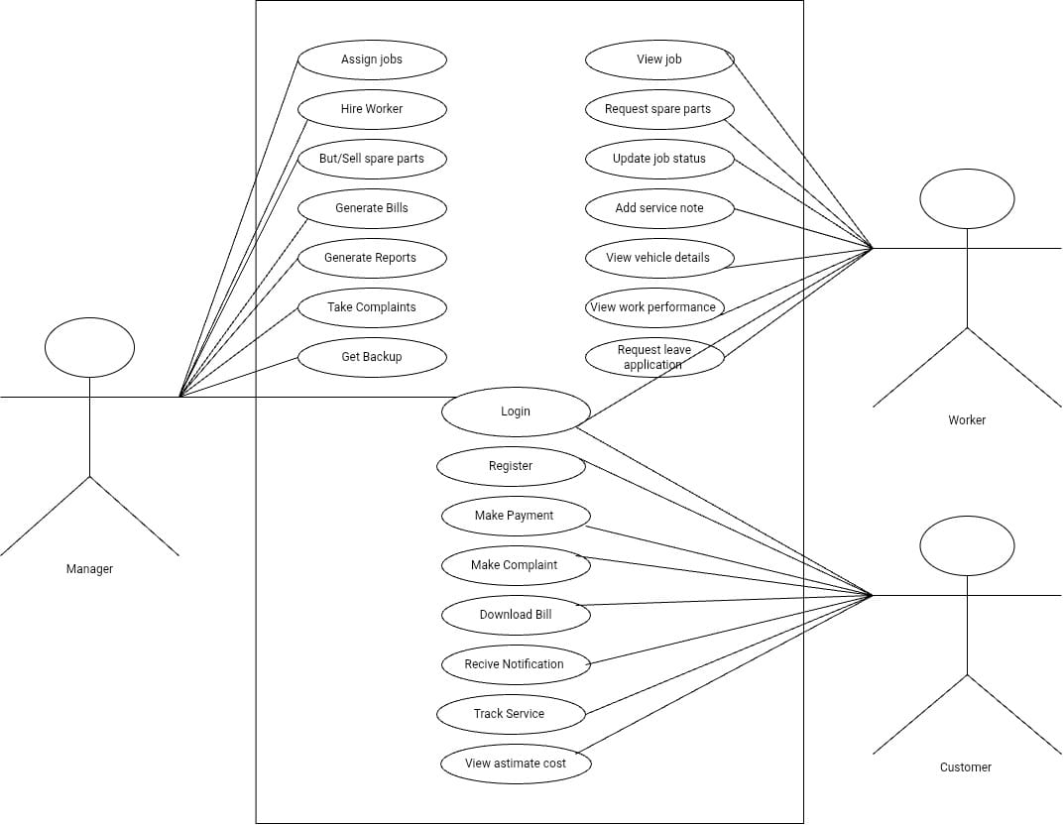
Figure 2.1-1 Use case diagram for car service management system

Activity diagram and Swimlane diagram

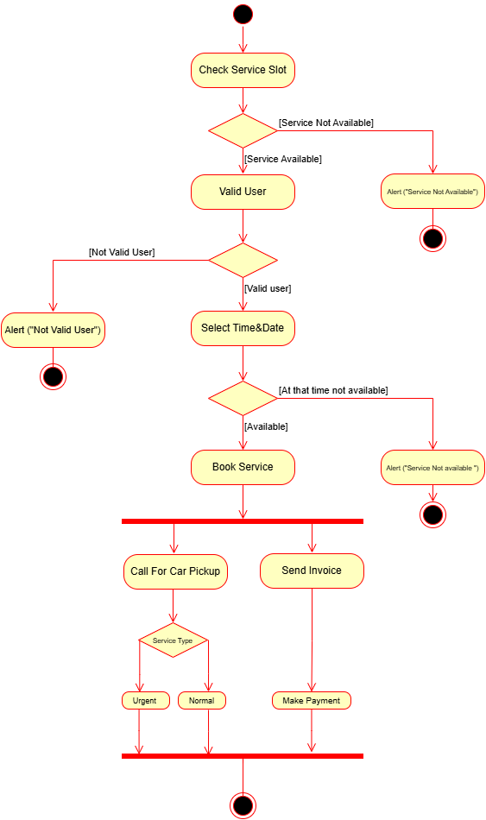
Figure 2.2-1 Activity diagram for service slot booking

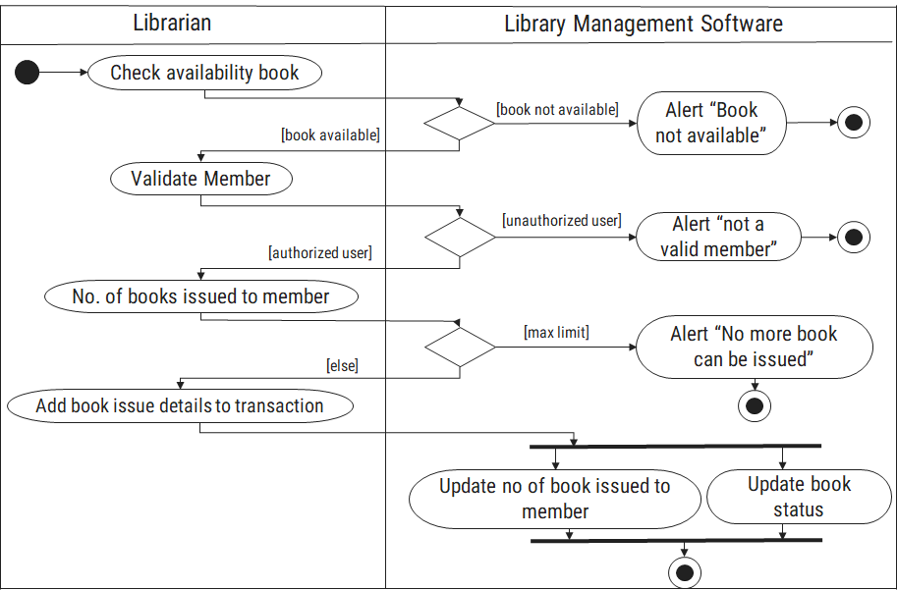
Figure 2.2-2 Swimlane diagram for Book Issue

Sequence diagram

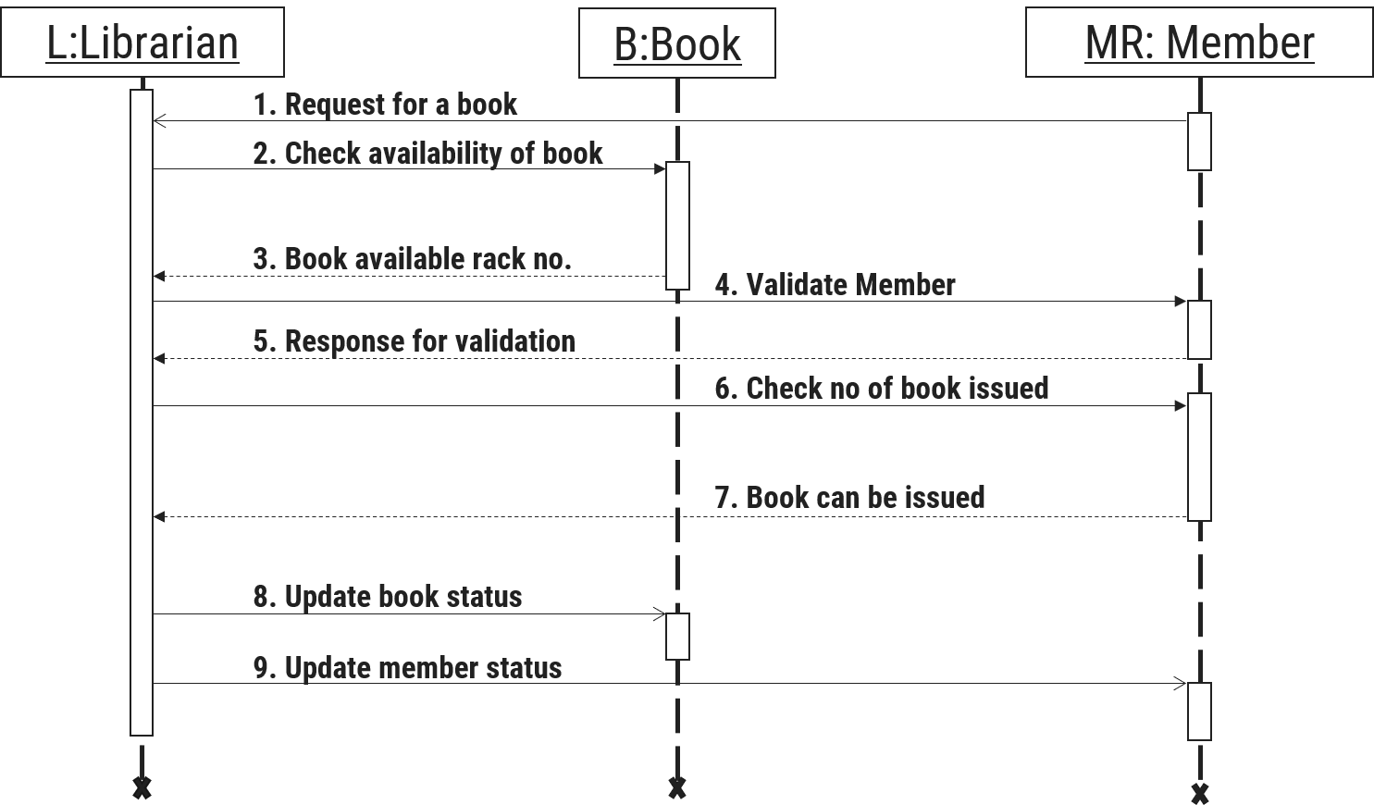
Figure 2.3-1 Sequence diagram for Book Issue

State diagram

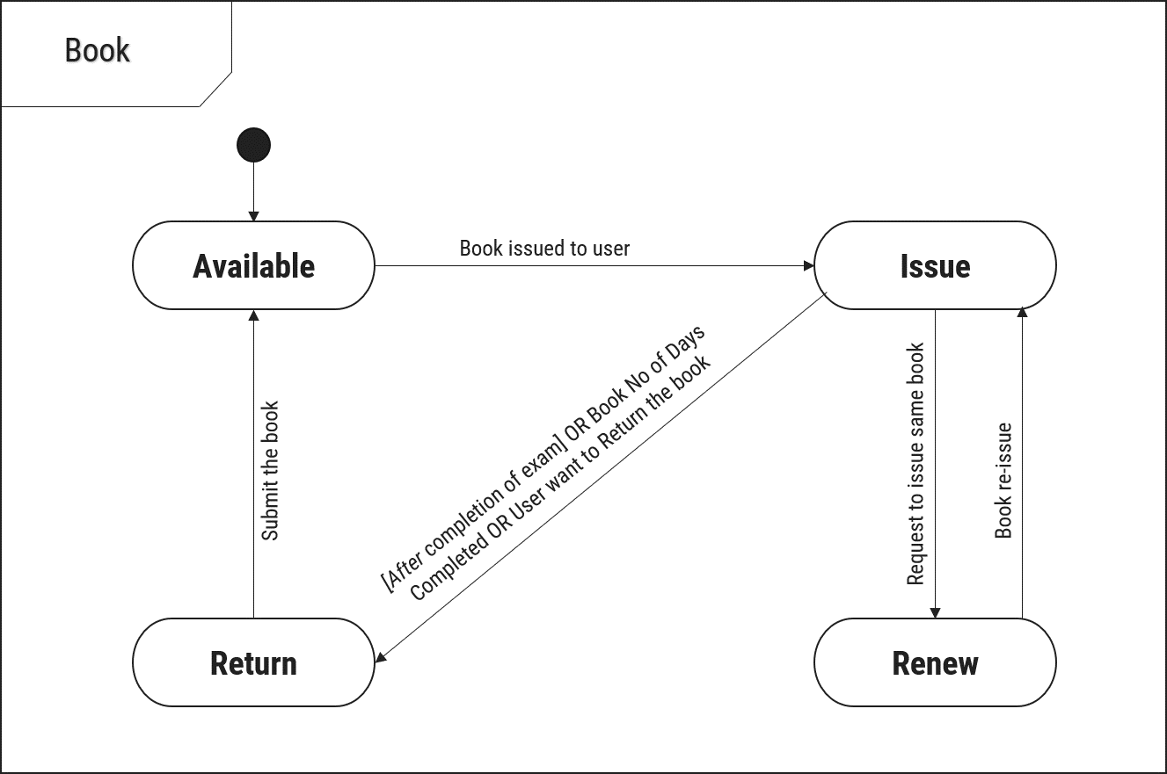
Figure 2.4-1 State diagram of Book

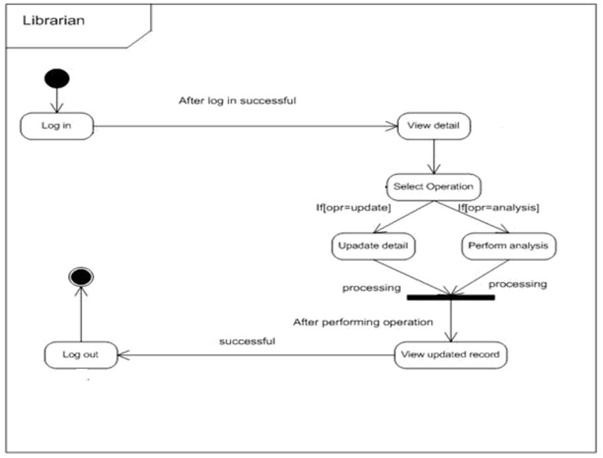
Figure 2.4-2 State diagram for Librarian

Class diagram

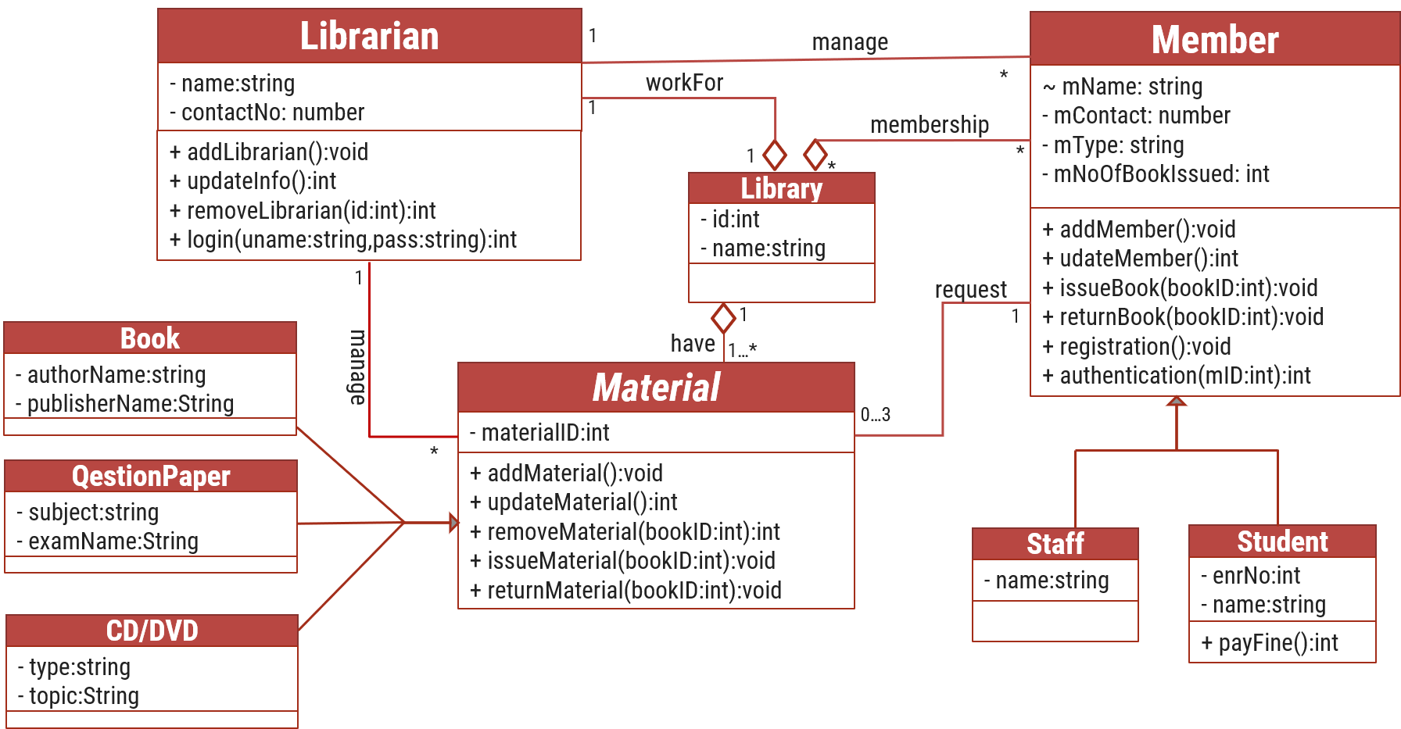
Figure 2.5-1 Class diagram for Library management system

Data flow diagram

Context diagram (level-0)
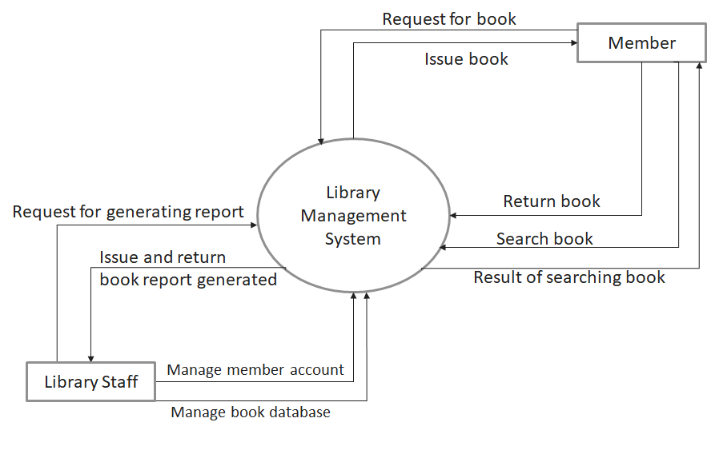
Figure 2.6-1 Context diagram for Library management system

DFD Level-1
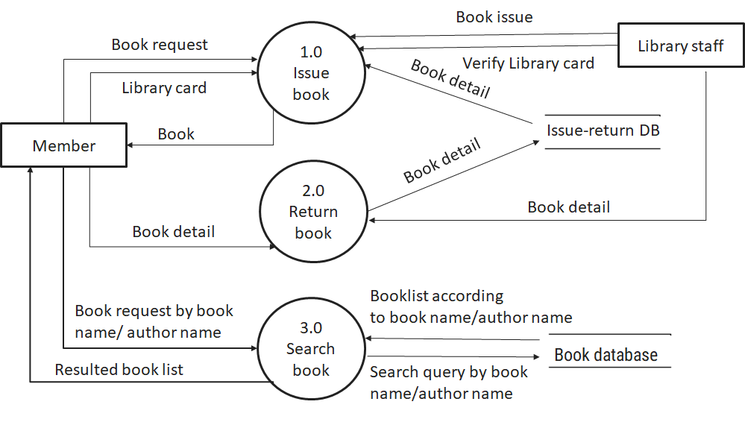
Figure 2.6-2 DFD level-1 for Library management system

DFD Level-2
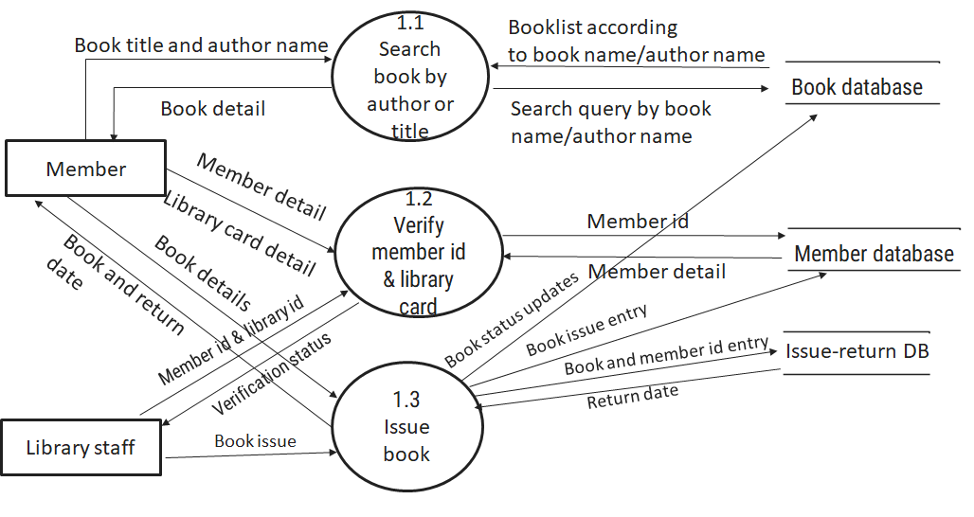
Figure 2.6-3 DFD level-2 for Issue book

External interface requirement (Screens)

Screen-1: Registration Form
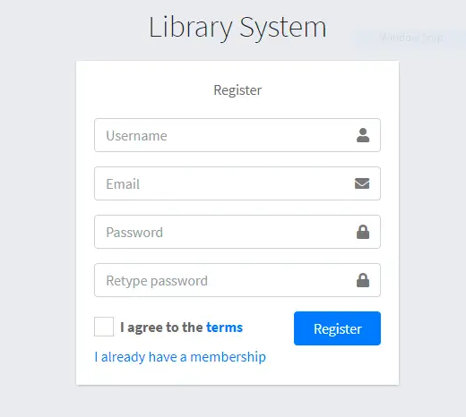
Figure 3.1-1 Screen-1: Registration Form

Purpose: This form will allow the target end-users to register in the system. To register , the following information will be encoded in the system.

Table 3.1-1 Screen element of Registration form
Sr. | Screen Element | Input Type | O/M | 1/N | Description
1 | Username | Textbox | M | 1 | Username field should be editable and accept the Username.
2 | Email | Textbox | M | 1 | Email field should be editable and accept the email with proper format.
3 | Password | Password | M | 1 | Password field should be editable and accept the password and display as star or dot.
4 | Retype password | Password | M | 1 | Retype Password field should be editable and accept the password and display as star or dot.
5 | I agree to the terms | Checkbox | M | 1 | Checkbox for accepting terms and condition.
6 | I already have a membership | Link | ------ | ------ | Link for navigate to login page for registered user.
7 | Register | Button | ------ | ------ | Register is a button for store the entered data into database.

Screen-2: Login Form
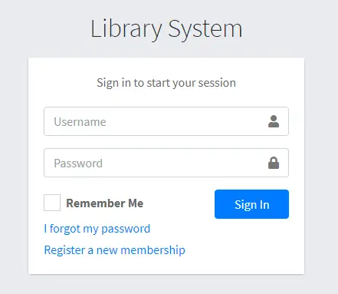
Figure 3.2-1 Screen-2: Login Form
Purpose: This form will be used by the system’s users to access records and features of the system. The users will input the correct combination of their username and password to be able to login to the system.

Table 3.2-1 Screen element of Login form
Sr. | Screen Element | Input Type | O/M | 1/N | Description
1 | Username | Textbox | M | 1 | Username field should be editable and accept the Username.
2 | Password | Password | M | 1 | Password field should be editable and accept the password and display as star or dot.
3 | Remember Me | Checkbox | M | 1 | Saving login credentials through remember me checkbox
4 | I forgot my password | Link | ------ | ------ | Link for navigate to Forgot password page for allows users to recover password.
5 | Register a new membership | Link | ------ | ------ | Link for navigate to membership registration.
6 | Sign in | Button | ------ | ------ | Login button navigates to another page even if valid login credentials.

Screen-3: Add borrower book
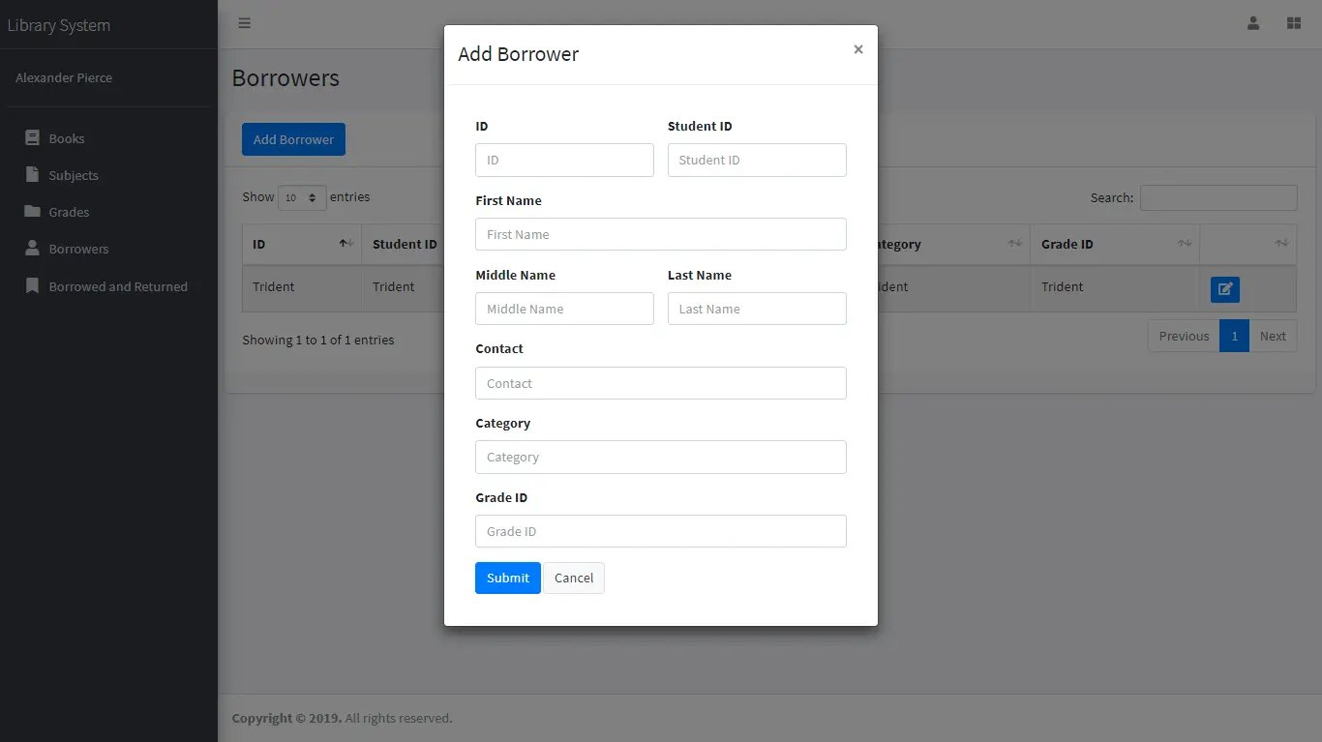
Figure 3.3-1 Screen-3: Add borrower book

Purpose: This module will allow the system administrator to add, edit, update or delete borrowers of book. The admin can add borrower information and manage it.

Table 3.3-1 Screen element of Add borrower book
Sr. | Screen Element | Input Type | O/M | 1/N | Description
1 | Borrower ID | Textbox | M | 1 | Borrower ID field should be editable and fill autogenerated Borrower ID.
2 | Student ID | Textbox | M | 1 | Student ID field should be editable and accept Student barcode id.
3 | First Name | Textbox | M | 1 | First Name field should be editable and accept only string as a borrower first name.
4 | Middle Name | Textbox | O | 1 | Middle Name field should be editable and accept only string as a borrower middle name.
5 | Last Name | Textbox | M | 1 | Last Name field should be editable and accept only string as a borrower last name.
6 | Contact | Textbox | M | 1 | Contact field should be editable and accept only 10-digit mobile number.
7 | Grade Id | Textbox | O | 1 | Auto fetch detail from the database if proper student id is entered.
8 | Submit | Button | ----- | ----- | Submit is a button for store the entered data into database.
9 | Cancel | Button | ----- | ----- | Cancel is a button for close add borrower dialog.

Database design

List of Tables
- Book
- Borrower
- Student
- Staff

Table 4.1-1 Table: Book
Column | Data Type | Null | Keys & Constrains | Default Value & Description
BookID | int | NN | PK (Auto Increment)
BookName | varchar(100) | NN
ISBN | varchar(100) | AN
Publication_year | int | AN
Language | varchar(50) | AN

Table 4.1-2 Table: Borrower
Column | Data Type | Null | Keys & Constrains | Default Value & Description
BorrowerID | int | NN | PK (Auto Increment)
BookID | varchar(100) | NN | FK | Reference of Book Table
BorrowedFromDate | DateTime | AN
BorrowedToDate | DateTime | AN
ActualReturnDate | DateTime | AN
IssuedBy | int | NN | FK | Reference of Student and Staff Table

Table 4.1-3 Table: Staff
Column | Data Type | Null | Keys & Constrains | Default Value & Description
StaffID | int | NN | PK (Auto Increment)
StaffName | varchar(100) | AN
IsAdmin | Boolean | AN
Designation | varchar(100) | AN

Table 4.1-4 Table: Student
Column | Data Type | Null | Keys & Constrains | Default Value & Description
StudentID | int | NN | PK (Auto Increment)
StudentName | varchar(100) | AN
Gender | varchar(100) | AN
DOB | DateTime | AN
Department | varchar(100) | AN
Contact | number(10,0) | AN

Stories and Scenario

Story-1: Add New Book in Library Catalogue

Story # S1 | : | As a Librarian,  I want to add a new book in library catalogue  So that everyone can easily find and borrow it.
Priority | : | High
Estimate | : | XL
Reason | : | The addition of a new book to the library catalogue is crucial for ensuring that the library's collection is up-to-date and accessible to everyone.

Scenario# S1.1
Scenario# S1.1 | : | Adding a New Book with Valid Information
Prerequisite | : | Librarian is logged in to the Library management system.
Acceptance Criteria | : | Given: The Librarian is navigated to the library catalog management page. Valid book information, including title, author, ISBN, and other relevant details is added.  When:  The librarian selects the "Add New Book" option  And The librarian enters valid book details  The librarian clicks the "Save" button to add the book to the catalog.  Then the system successfully adds the book to the catalog and the librarian receives a confirmation message with the book's identification number.

Scenario# S1.2
Scenario# S1.2 | : | Adding a New Book with Invalid Information.
Prerequisite | : | The librarian is logged into the library management system.
Acceptance Criteria | : | Given: The librarian is on the library catalogue management page  When: The librarian selects the "Add New Book" option and the librarian enters an incomplete or incorrect book details and librarian clicks the "Save" button to add the book to the catalogue.  Then the system displays error messages for the incorrect or missing information and the book is not added to the catalogue.

Scenario# S1.3
Scenario# S1.3 | : | Attempting to Add a Duplicate Book
Prerequisite | : | The librarian is logged into the library management system and the librarian is on the library catalogue management page
Acceptance Criteria | : | Given: The book information, including title, author, ISBN, and other relevant details, is available and the book with the same ISBN is already in the catalogue.  When: User Clicks on “Add book” button. Enter a number of copies with the same book detail mentioned in the field.  Then: Generate unique book id, barcode and spine label for various book of same title.

Story-2: Search Book
Story # S2 | : | As a Librarian or member,  I want to search for books by title, author, or keyword,  So that I can quickly find books that match my interests.
Priority | : | High
Estimate | : | M
Reason | : | Implementing a search functionality is essential for enhancing the user experience, as it allows librarian and member to efficiently discover and access the library's resources.

Story-3: Manage due date for borrowed book
Story # S3 | : | As Librarian,  I want to manage due dates for borrowed books  So that I can ensure that books are returned on time and avoid overdue fines.
Priority | : | High
Estimate | : | M
Reason | : | Proper due date management is crucial for maintaining the library's collection and ensuring that books are available for all members.

Story-4: Renew book
Story # S3 | : | As Librarian,  I want to renew a book that I have borrowed  So that I can extend my borrowing period if needed.
Priority | : | Medium
Estimate | : | M
Reason | : | Book renewal functionality is a convenience feature for librarian, allowing them to keep a book for an extended period if no one else has requested it.

Story-5: Generate a report on book usage and availability
Story # S3 | : | As Librarian,  I want to generate reports on library usage and book availability  So that I can make informed decisions about library’s books.
Priority | : | Medium
Estimate | : | L
Reason | : | Reporting functionality helps librarians track the usage of library resources and make data-driven decisions to improve services and collections.

Test cases
Project Name: | EMI Calculator | Test Designed by: | P. U. Jadeja
Module Name: | Login | Test Designed date: | 01-10-2023
Release Version: | 1.0 | Test Executed by: | R. B. Gondaliya
 |  | Test Execution date: | 15-01-2023

Pre-condition: Web application should be accessible
Test Case ID | Test Title | Test Type | Description | Test Case ID
TC_001 | Login to web application with valid credential | Functional | Login to Library management system web application through valid credential | TC_001
TC_002 | Login to web application with invalid credential | Functional | Login to Library management system web application through invalid credential | TC_002
TC_003 | Varify login page elements | GUI | varify that all elements are availabe on login page | TC_003

Test Case Title | Login to web application with valid credential
Test Type | Functional
Test Priority | High
Pre-condition | Web application should be accessible

Test Step | Test Case Description | Expected Result | Actual Result | Status | Comment | Data | BUG ID
1 | Access Web application URL | The site launched properly | Site launched successfully | Pass |  | https://accounts.google.com/ServiceLogin
2 | Enter valid Username in username field | Username field should be editable and accept the Username | Username input accepted | Pass |  | Username:  Rbgondaliya@gmail.com
3 | Enter valid Password in Password field | Password field should be editable and accept the password and display as star or dot | Password input displayed in dot and accepted | pass |  | Password:  rbgondaliya
4 | Enter valid captcha code in captch field | Captch field should editable and accept captcha and captcha is case sensitive | Captcha input accepted | Pass | Step required when human action validation perform | get captcha from image which is near by captcha field
5 | Click on login button | User should login into site and navigated to dashboard | User navigated to dashboard and username should br display in top of the right side. | pass

Test Case Title | Login to web application with invalid credential
Test Type | Functional
Test Priority | Medium
Pre-condition | Web application should be accessible

Test Step | Test Case Description | Expected Result | Actual Result | Status | Comment | Data | Bug ID
1 | Verify that User is not able to Login with invalid Username and invalid Password | Should be display an error message enter wrong username or password | Display an error of wrong username and password | Pass
2 | Verify that User is not able to Login with Valid Username and invalid Password | Should be display an error message enter wrong password | Display an error of wrong password | Pass
3 | Verify that User is not able to Login with invalid Username and Valid Password | Should be display an error message User not found | Display an error Username not found | Pass
4 | Verify that User is not able to Login with blank Username or Password | Set required field validation message for Username and Password | Display an error of wrong username and password | Fail | Not performa a validation function fix it |  | Bug_002

Test Case Title | Varify login page elements
Test Type | GUI
Test Priority | Medium
Pre-condition | Web application should be accessible

Test Step | Test Case Description | Expected Result | Actual Result | Status | Comment | Data | Bug ID
1 | Launch application with the given url | The site launched properly | Site launched successfully | Pass |  | https://accounts.google.com/ServiceLogin
2 | Verify that the login screen contains elements such as Username, Password, Sign in button, Remember password check box, Forgot password link, and Create an account link. | All listed control displayed properly on the page | Login page loaded successfully | Pass
3 | Verify that cursor is focused on “Username” text box on the page load | Cursor is focused in Username textbox | Cursor focus in Username textbox | Pass
4 | Verify that tab functionality is working properly or not | When tab pressed cursor move in next control | Cursor moving in next control | Pass
5 | Verify that all the fields such as Username, Password has a valid placeholder | All text fields have proper placeholder | All text fields have proper placeholder | Pass
6 | Verify that the labels float upward when the text field is in focus or filled (In case of floating label) | When field is focused or filled, label display on top of the filled | When field is focus or filled, label display on top of the filled | Pass | step required when fields with floating label
7 | verify that forgot password link working properly | when click on forgot password load forgot passworg page | forgot password link not working | Fail

References

- http://www.w3schools.com/html/html_intro.asp
- https://www.w3schools.com/php/default.asp
- https://www.javatpoint.com/uml

